FOOD MANAGEMENT SYSTEM

Use-Case Specification: Display product details

Version <1.0>

Revision History

|  |  |  |  |
| --- | --- | --- | --- |
| **Date** | **Version** | **Description** | **Author** |
| <7/12/2020> | <1.0> | <details> | <Nguyen Thu Trang> |

Table of Contents

1. Use-Case Name 4

1.1 Brief Description 4

2. Flow of Events 4

2.1 Basic flow 4

2.2 Alternative flow 4

2.2.1 <First Alternative flow> 4

2.2.1 <Second Alternative flow> 4

3. Special Requirement 4

3.1 <First Special Requirement> 4

4. Preconditions 4

4.1 <Precondition One> 4

5. Posstcondition 4

5.1 <Postcondition One> 4

6. Extension Points 5

6.1 < Name of Extension Points> 5

Use-Case Specification: Display product details

1. **View product details**
   1. **Brief Description**

This use case defines the view of products in detail. The system allow customer view the detail of products ( name, price, image, etc).

* 1. **Actor**

System

1. **Flow of Events**
   1. **Basic Flow**

First, customer login the system and then click on the image of product which want to view. The system display information of this product in detail.

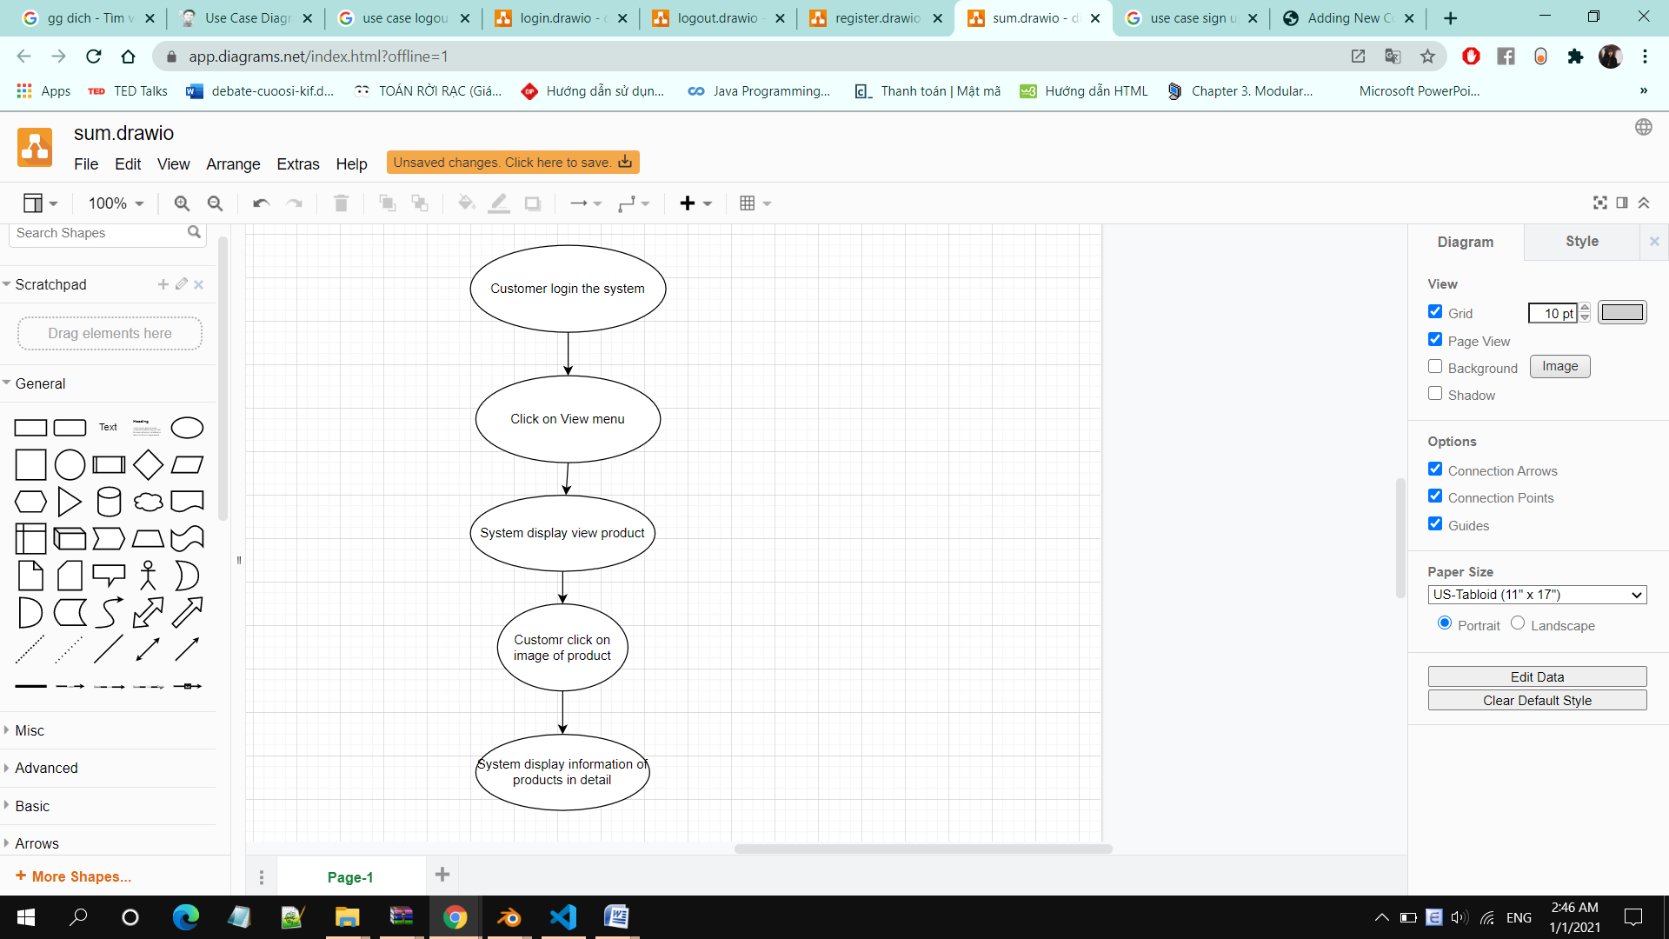

1. **Special Requirements**

Customer must know how to use the product management system.

1. **Preconditions**

Customer already has an accountand log in successful

1. **Postconditions**

Customer views the entire the list of the product

1. **Extension Points**

No extension points.